 | REPUBLIC OF VANUATU  DEPARTMENT OF CLIMATE CHANGE  Ministry of Climate Change and Natural Disasters  Private Mail Bag 9054, Port Vila  Telephone: (678) 22160; Email: docc@vanuatu.gov.vu; | 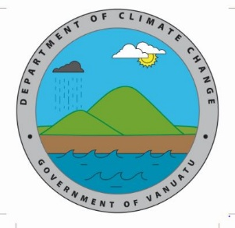

Climate Change Adaptation & Mitigation Stakeholders Mapping Matrix

Organization | Project/Program | Type  (Completed/Past, Current, Proposed) | Project Duration | Location (s) | Adaptation  Activity Specification | Mitigation Activity Specification | DRR Activity Specification | Linkage to the CCDRR Policy (insert relevant reference number – see attached sheet) | Government Sector Partner  Engagement? | Funding source | Any IEC materials produced? If yes, please give details? | Have you used the NAB Portal before? | Contact Person | Contact Details

Linkage to CCDRR policy priorities
Strategic Areas | Priority Actions Reference number
1. Governance | 1.1 Institutional Structures
 | 1.2 Legislation and Policy frameworks
 | 1.3 International and Regional obligations
 | 1.4 Strategic and Business Plans
2. Finance | 2.1 Funding allocations
 | 2.2 Implementing Entity Accreditation
 | 2.3 Small Grants scheme
3. Knowledge and Information | 3.1 Information management
 | 3.2 Traditional knowledge
 | 3.3 Knowledge sharing
 | 3.4 Lessons learned
 | 3.5 Data analysis
 | 3.6 Research
 | 3.7 Risk assessment
4. Climate Change Adaptation and Disaster Risk Reduction | 4.1 Climate and Disaster Vulnerability and Multi sector impact assessment
 | 4.2 Integrated climate change adaptation and disaster risk reduction
 | 4.3 Community based adaptation and disaster risk reduction
 | 4.4 Loss and Damage
 | 4.5 Ecosystem based adaptation
5. Low carbon development | 5.1 Energy Roadmap, Renewable energy and energy efficiency
 | 5.2 Mitigation and REDD+
6. Response and Recovery | 6.1 Planning
 | 6.2 Preparedness
 | 6.3 Community awareness
 | 6.4 Early warning systems
 | 6.5 Post disaster assessment
 | 6.6 Recovery

